

MEDICINE safe

By Sem Boonen and Daan Swinters



1 januari 2021

content

1.1. released project 2

1.2. Steps 3

1.2.1. Step 1: 3

1.2.2. Step 2: 4

1.2.3. Step 3: 5

1.2.4. Step 4: 6

1.2.5. Step 5: 6

1.2.6. Step 6: 7

1.2.7. Step 7: 8

1.2.8. Step 8: 9

1.2.9. Step 9: 10

1.2.10. Step 10: 11

1.2.11. Step 11: 12

1.2.12. Step 12: 13

1.2.13. Step 13: 14

1.2.14. Step 14: 15

1.2.15. Step 15: 16

1.2.16. Step 16: 17

1.2.17. Step 17: 18

1.2.18. Step 18: 18

1.2.19. Step 19: 19

1.2.20. Step 20: 20

1.2.21. Step 21: 21

1.2.22. Step 22: 22

1.2.23. Step 23: 23

1.2.24. Step 24: 23

1.2.25. Step 25: 24

1.3. Arduino 24

1.3.1. Electric schema : 25

1.4. Installation: 26

# released project

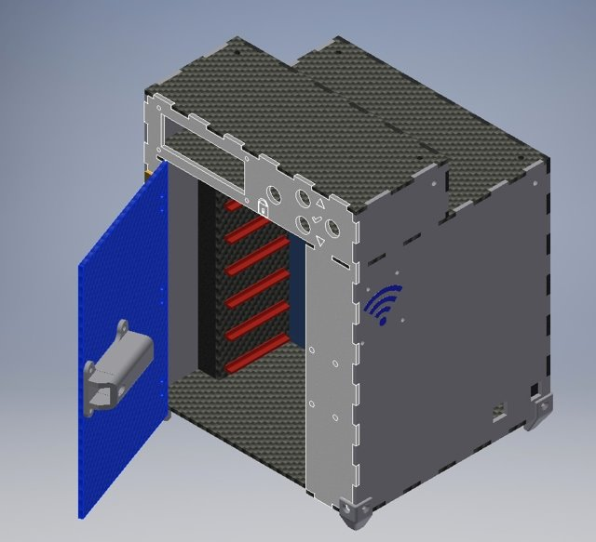

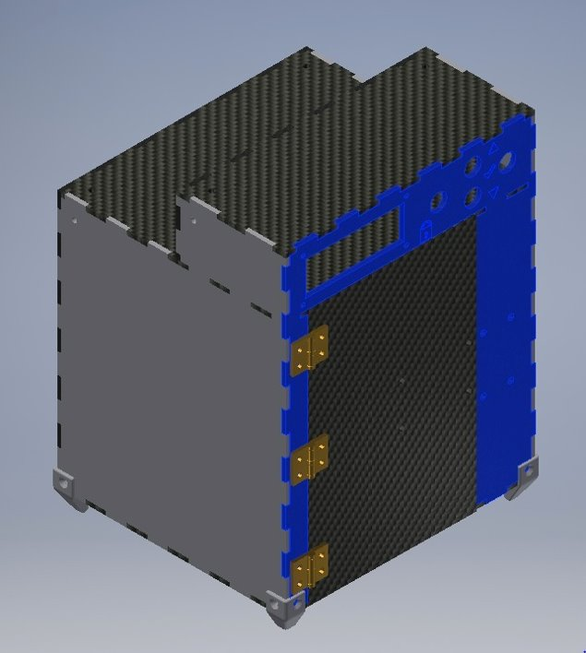

# Steps

# Step 1:

Laser or print all parts (see [githup](https://github.com/DSCodings/Medicin-Locker)):

[printed parts:](https://github.com/DSCodings/Medicin-Locker/tree/Medicin-locker/English/Files/3D%20printer%20STL%20files)

1x: [14 lock pin sleeve large](https://github.com/DSCodings/Medicin-Locker/blob/Medicin-locker/English/Files/3D%20printer%20STL%20files/14%20lock%20pin%20sleeve%20large.stl)

1x: [15 lock pin sleeve smal](https://github.com/DSCodings/Medicin-Locker/blob/Medicin-locker/English/Files/3D%20printer%20STL%20files/15%20lock%20pin%20sleeve%20smal.stl)

1x: [17 lock counter pin](https://github.com/DSCodings/Medicin-Locker/blob/Medicin-locker/English/Files/3D%20printer%20STL%20files/17%20lock%20counter%20pin.stl)

1x: [18 pin shooter](https://github.com/DSCodings/Medicin-Locker/blob/Medicin-locker/English/Files/3D%20printer%20STL%20files/18%20pin%20shooter.stl)

14x: [19 tray shelf](https://github.com/DSCodings/Medicin-Locker/blob/Medicin-locker/English/Files/3D%20printer%20STL%20files/19%20tray%20shelf.stl)

4x: [22 leg mounting corners](https://github.com/DSCodings/Medicin-Locker/blob/Medicin-locker/English/Files/3D%20printer%20STL%20files/22%20leg%20mounting%20corners.stl)

4x: [22.1 mounting brackets instead of bolts](https://github.com/DSCodings/Medicin-Locker/blob/Medicin-locker/English/Files/3D%20printer%20STL%20files/22.1%20mounting%20brackets%20instead%20of%20bolts.stl)

4x [23 mounting brackets 3 sides](https://github.com/DSCodings/Medicin-Locker/blob/Medicin-locker/English/Files/3D%20printer%20STL%20files/23%20mounting%20brackets%203%20sides.stl)

2x: [24 fixing corners 2 sides](https://github.com/DSCodings/Medicin-Locker/blob/Medicin-locker/English/Files/3D%20printer%20STL%20files/24%20fixing%20corners%202%20sides.stl)

1x: [27 servo arm](https://github.com/DSCodings/Medicin-Locker/blob/Medicin-locker/English/Files/3D%20printer%20STL%20files/27%20servo%20arm.stl)

3x: [26.2 hinge 0.2mm clearance](https://github.com/DSCodings/Medicin-Locker/blob/Medicin-locker/Nederlands/Bestanden/3D%20printer%20STL%20files/26.2%20scharnier%200.3%20mm%20speling.stl) or [26 hinge 0.2mm clearance](https://github.com/DSCodings/Medicin-Locker/blob/Medicin-locker/English/Files/3D%20printer%20STL%20files/26%20hinge%200.2mm%20clearance.stl)

(If your printer is very accurate the 0.2mm would not be a problem, if you want to be sure use the 0.3mm)

1x: [25 door handle](https://github.com/DSCodings/Medicin-Locker/blob/Medicin-locker/English/Files/3D%20printer%20STL%20files/25%20door%20handle.stl)

1x [16 slot servo holder](https://github.com/DSCodings/Medicin-Locker/blob/Medicin-locker/English/Files/3D%20printer%20STL%20files/16%20slot%20servo%20holder.stl)

[Lasered parts(3mm thickness plate):](https://github.com/DSCodings/Medicin-Locker/tree/Medicin-locker/English/Files/Lazer%20DXF%20files)

[All 1x:](https://github.com/DSCodings/Medicin-Locker/tree/Medicin-locker/English/Files/Lazer%20DXF%20files)

Make sure you arrange the plates as on the picture below:

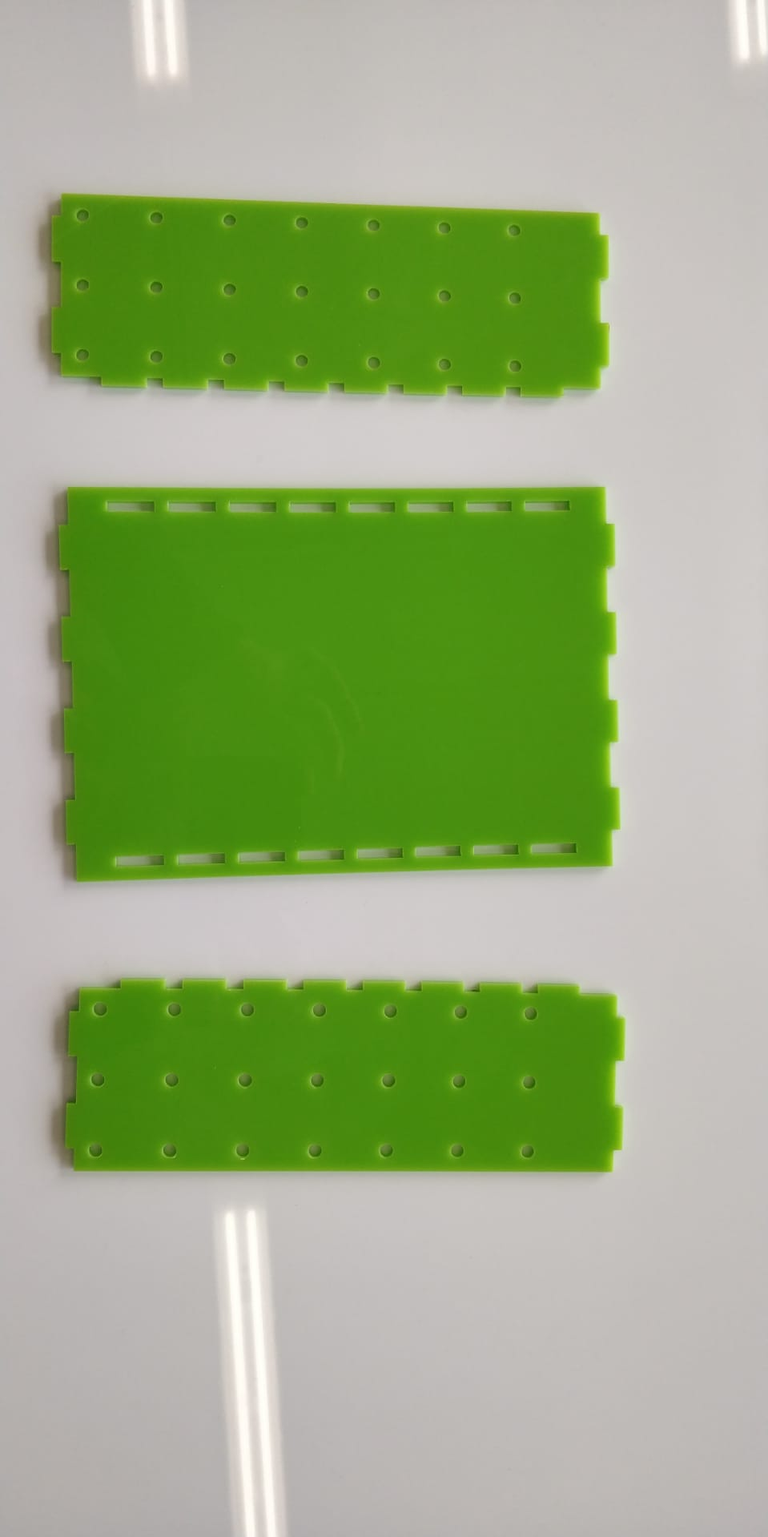

# Step 2:

Build the plates together as shown below and search the bottom plate.

# Step 3:

Put the construction on the base plate and search the left cover plate.

# Step 4:

Connect the cover plates as shown below and search the top plate

# Step 5:

Connect now the top plate and search the next plate

# Step 6:

Put the plate on top of the construction and search the side plates. and the RFID, to the you connect the cables to the Arduino you can find the electrical diagram here, you screw it on with m3 nuts on the inside and bolts on the outside. You let the cables go through the built in hole.

Bij de zi

# Step 7:

Place the side plates as shown below. Make sure the plate with the loge is placed on the right.

Search the front plate

# Step 8:

Place the 4 buttons (14x20mm, hole 12mm), You can adapt the size of the holes if you want to use your own ([github](https://github.com/DSCodings/Medicin-Locker).) and solder the wires to the buttons and place it into the front plate.

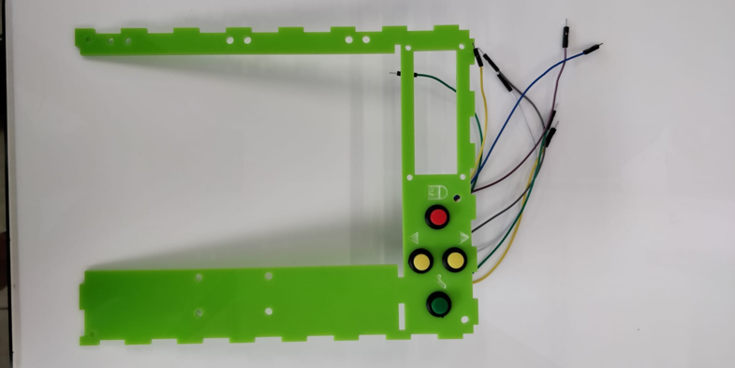

# Step 9:

Take the LCD and bend the headers as shown in the picture below.

Place the LCD in the rectangle (fix it with the M3 nuts and bolts and spacers if needed to Alling the lcd)

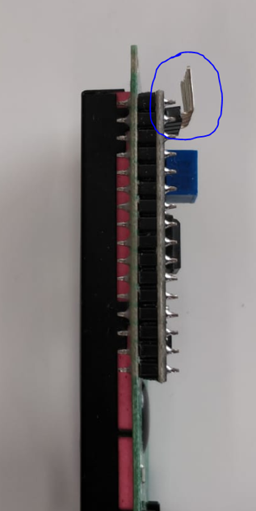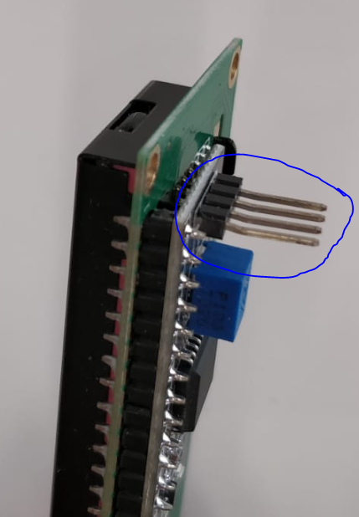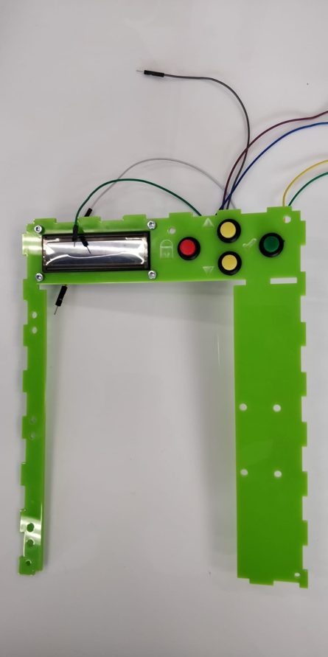

# Step 10:

Build the construction below with the servo, servo arm and pin. Fix the servo with screws.

This will be used as lock.

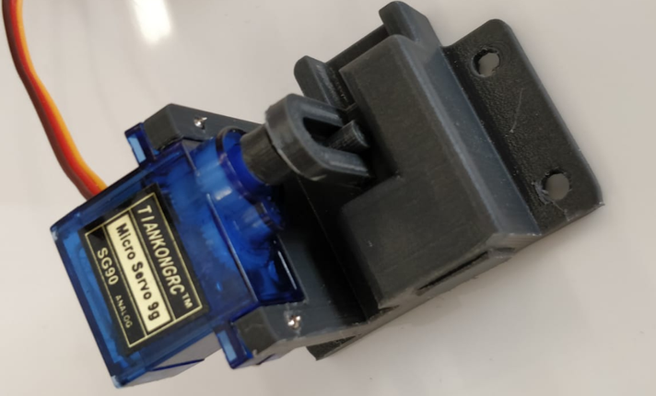

# Step 11:

Place the slot on the 4 holes of the front plate and fix it with 4 M4 bolts and nuts.

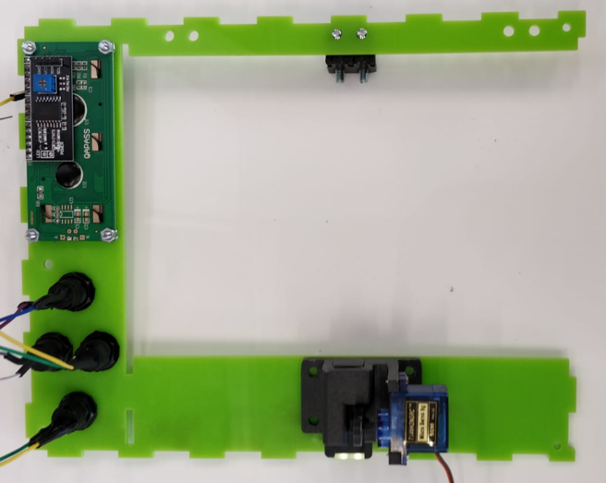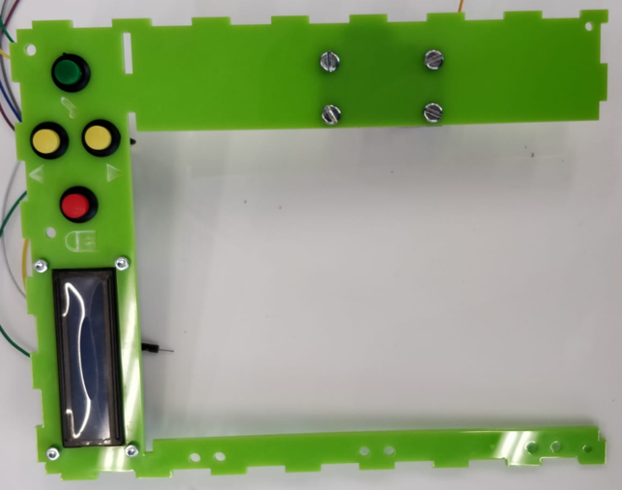

# Step 12:

Now find the door plate, doorhandle, pin sleeve small/large, shooter pin and a spring. Mount the small pin sleeve and the doorknob to the outer holes, but on opposite sides (make sure the slanted side of the sleeve is on the outside, **with M4 bolts and nuts**). Insert the spring into the large sleeve and then the striker pin with the beveled side out and the protruding cylinder into the slot of the sleeve. Mount the large sleeve to the middle 2 of the door on the same side as the small sleeve (put the shooter into the small sleeve as well, **also with M4 bolts and nuts**).

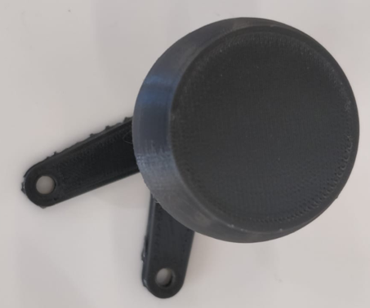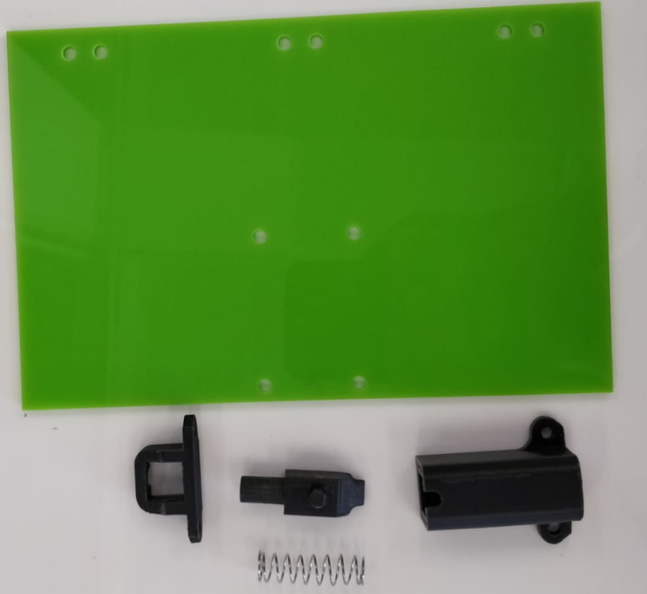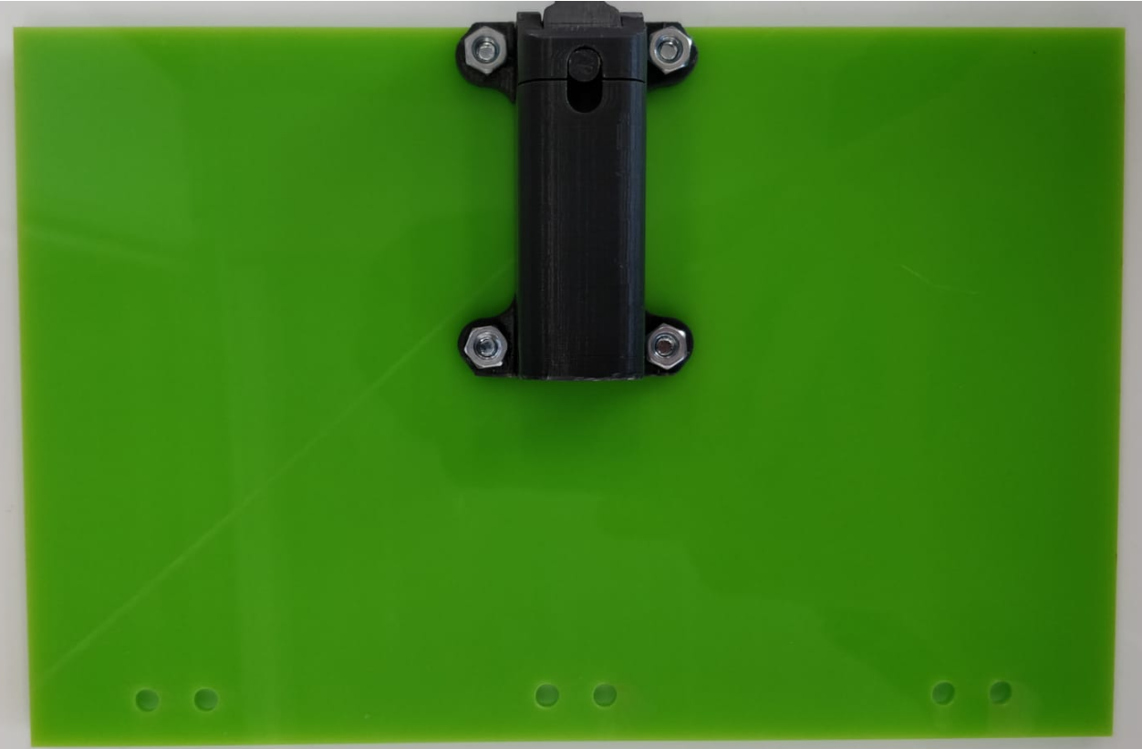

# Step 13:

Find the hinges and mount them to the door with M4 bolts and nuts (place the hinges on the outside of the door (make sure the button of the hinge is pointing outwards)

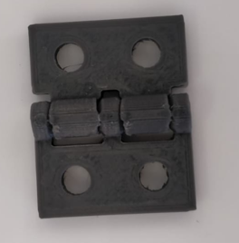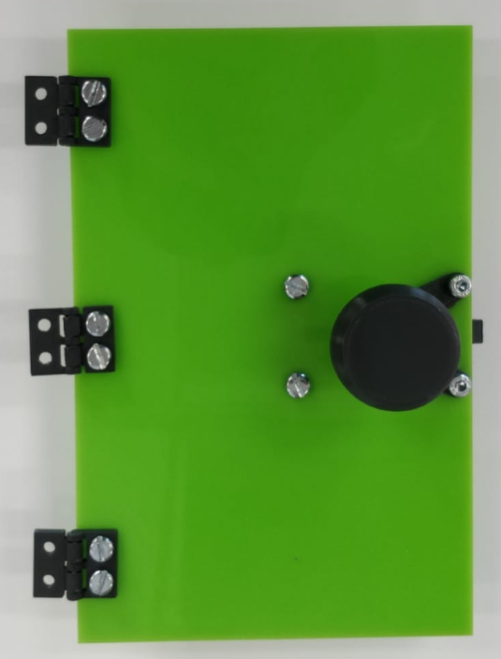

# Step 14:

Now mount the remaining mounting points of the hinges to the front plate also with M4 bolts and nuts.

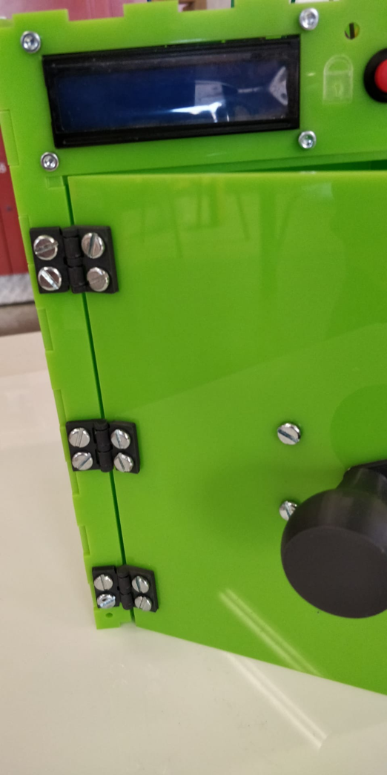

# Step 15:

Place the front plate like the picture below: also find the parts below and with a little glue attach the nut of m4, you do this 2 times.

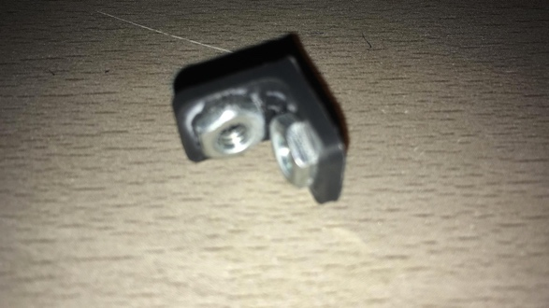

# Step 16:

Then screw it down like the pictures below with m4 bolts.

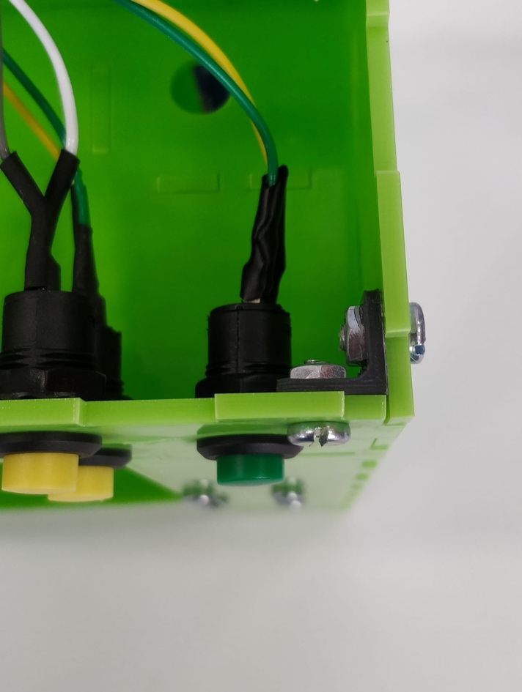 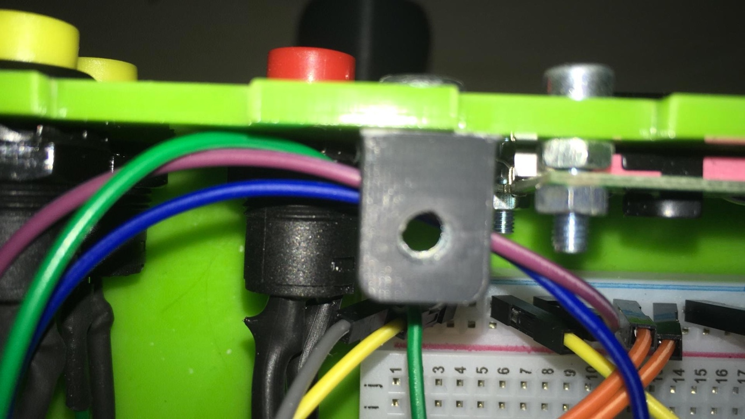

# Step 17:

Take the 4 3-sided connecting angles and 12 M4 nuts, place the nuts in the indentations of the angles and secure them with a bit of super glue.

# Step 18:

These corners hold the cabinet together at these 4 points with flathead M4 bolts (for now, attach them to the sides you have already assembled with the 3rd side pointing out). 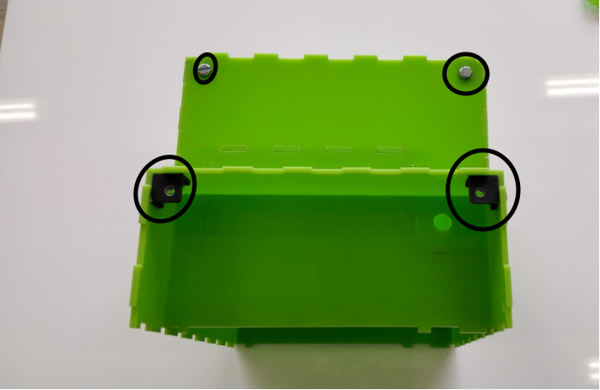

# Step 19:

You attach the Arduino with 3 nuts of M4 and bolts to put it at the right, put 3 bolts of m4 under the Arduino. make sure the usb input of the Arduino is in the front hole and the power adapter input is from below.

# Step 20:

Then you solder everything on to a breadboard on top of the top plate as below . See connection on the picture below.

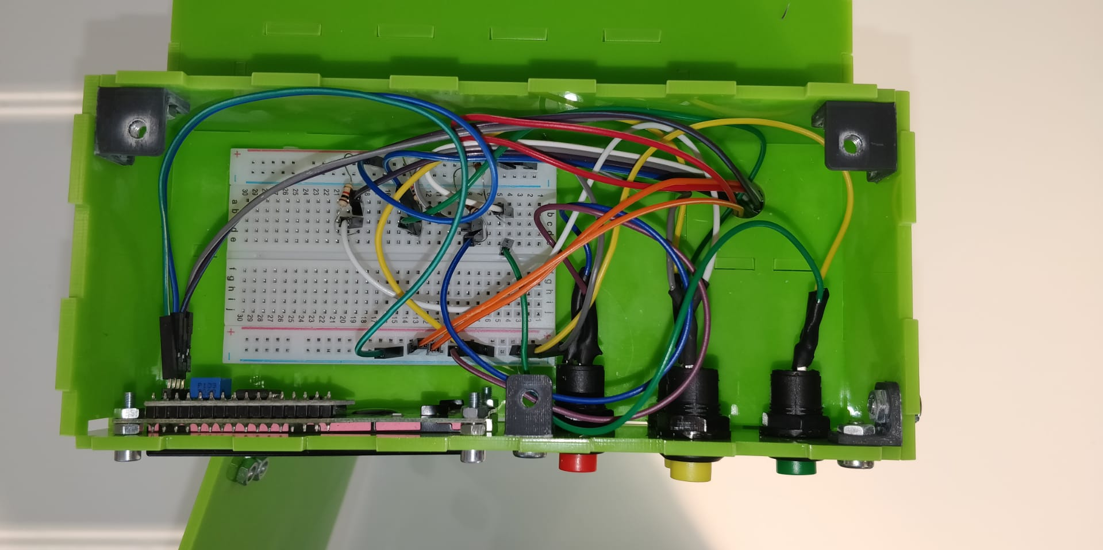

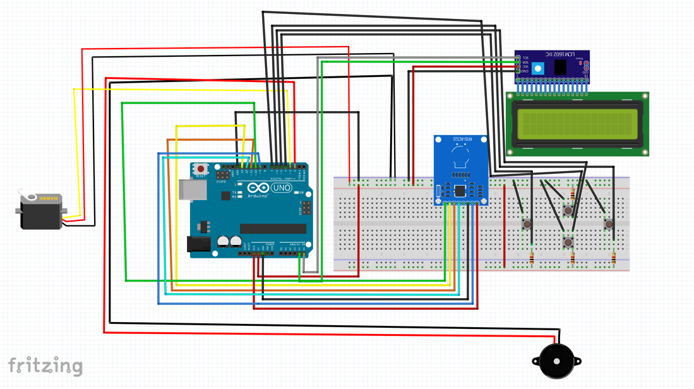

# Step 21:

Then you plug the cables into the Arduino. It’s possible that you have too few 5V ports, it depends on Arduino uno, then you must solder the 5v ports together. See electrical diagram below on how to connect it.

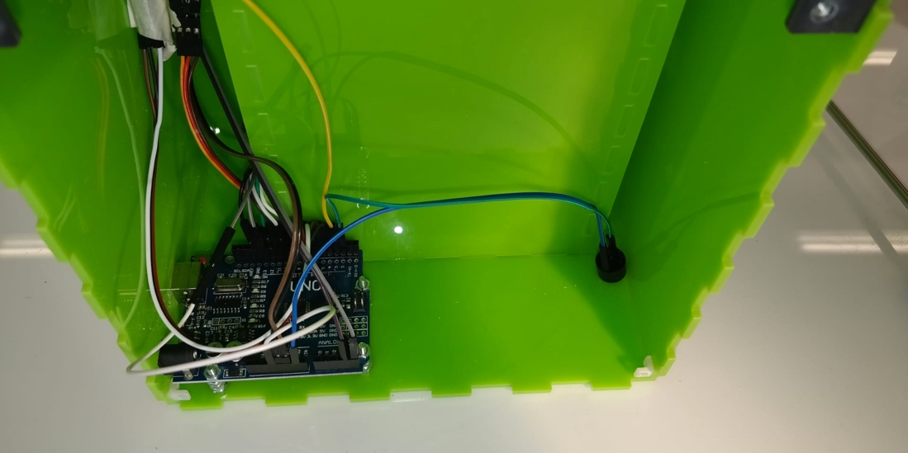



# Step 22:

After this, you take (a jar) and an M3 (countersunk bolt), screw it down along the outside with a corner piece with the M3 bolt. You do this for both sides of the front plate. Use the connection cookies (shown in white) instead of nuts, these will be tapped in when you screw in the bolts. 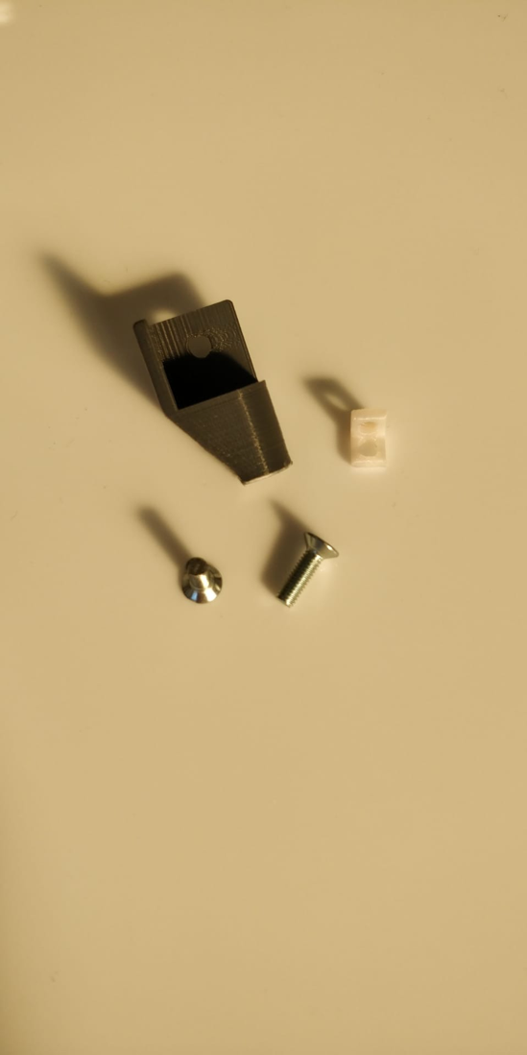

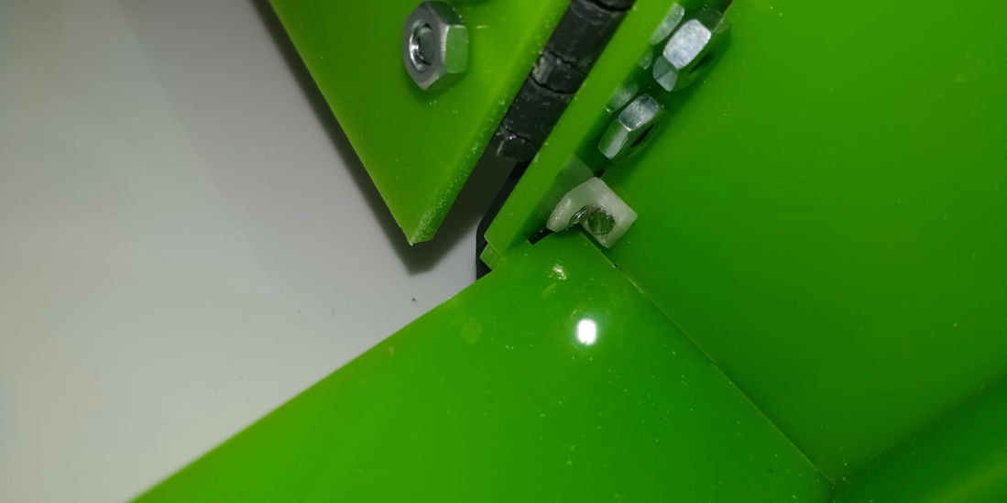

# Step 23:

Do the same with the back plate (use a little glue to hold the connecting corners in place when the back plate is in place).

# Step 24:

Then you take the layering for the benches and put them in place, you can't stick the layering wrong. 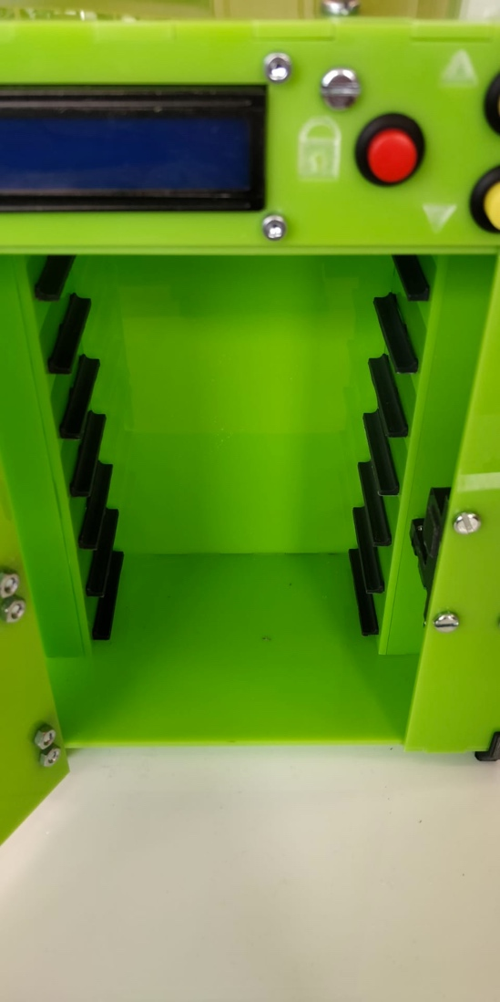

# Step 25:

Then find the top plate and 3 bolts of M4 and screw it on like the picture below.

# Arduino

1.3.1. Supplies:

1X: rfid-RC522 + batch/card

1X: arduino uno

1X: Servo SG90

1X: 1602 LCD I2c

1X: buzzor

4X buttons (14x20 round hole 12mm)

1x ac/dc adapter (6v)

Laser or print all parts (see [githup](https://github.com/DSCodings/Medicin-Locker)):

[printed parts:](https://github.com/DSCodings/Medicin-Locker/tree/Medicin-locker/English/Files/3D%20printer%20STL%20files)

1x: [14 lock pin sleeve large](https://github.com/DSCodings/Medicin-Locker/blob/Medicin-locker/English/Files/3D%20printer%20STL%20files/14%20lock%20pin%20sleeve%20large.stl)

1x: [15 lock pin sleeve smal](https://github.com/DSCodings/Medicin-Locker/blob/Medicin-locker/English/Files/3D%20printer%20STL%20files/15%20lock%20pin%20sleeve%20smal.stl)

1x: [17 lock counter pin](https://github.com/DSCodings/Medicin-Locker/blob/Medicin-locker/English/Files/3D%20printer%20STL%20files/17%20lock%20counter%20pin.stl)

1x: [18 pin shooter](https://github.com/DSCodings/Medicin-Locker/blob/Medicin-locker/English/Files/3D%20printer%20STL%20files/18%20pin%20shooter.stl)

14x: [19 tray shelf](https://github.com/DSCodings/Medicin-Locker/blob/Medicin-locker/English/Files/3D%20printer%20STL%20files/19%20tray%20shelf.stl)

4x: [22 leg mounting corners](https://github.com/DSCodings/Medicin-Locker/blob/Medicin-locker/English/Files/3D%20printer%20STL%20files/22%20leg%20mounting%20corners.stl)

4x: [22.1 mounting brackets instead of bolts](https://github.com/DSCodings/Medicin-Locker/blob/Medicin-locker/English/Files/3D%20printer%20STL%20files/22.1%20mounting%20brackets%20instead%20of%20bolts.stl)

4x [23 mounting brackets 3 sides](https://github.com/DSCodings/Medicin-Locker/blob/Medicin-locker/English/Files/3D%20printer%20STL%20files/23%20mounting%20brackets%203%20sides.stl)

2x: [24 fixing corners 2 sides](https://github.com/DSCodings/Medicin-Locker/blob/Medicin-locker/English/Files/3D%20printer%20STL%20files/24%20fixing%20corners%202%20sides.stl)

1x: [27 servo arm](https://github.com/DSCodings/Medicin-Locker/blob/Medicin-locker/English/Files/3D%20printer%20STL%20files/27%20servo%20arm.stl)

3x: [26.2 hinge 0.2mm clearance](https://github.com/DSCodings/Medicin-Locker/blob/Medicin-locker/Nederlands/Bestanden/3D%20printer%20STL%20files/26.2%20scharnier%200.3%20mm%20speling.stl) of [26 hinge 0.2mm clearance](https://github.com/DSCodings/Medicin-Locker/blob/Medicin-locker/English/Files/3D%20printer%20STL%20files/26%20hinge%200.2mm%20clearance.stl)

(If you printer is very accurate the 0.2mm would not be a problem, if you want to be sure use the 0.3mm)

1x: [25 door handle](https://github.com/DSCodings/Medicin-Locker/blob/Medicin-locker/English/Files/3D%20printer%20STL%20files/25%20door%20handle.stl)

1x [16 slot servo holder](https://github.com/DSCodings/Medicin-Locker/blob/Medicin-locker/English/Files/3D%20printer%20STL%20files/16%20slot%20servo%20holder.stl)

[Lasered parts(3mm thickness plate):](https://github.com/DSCodings/Medicin-Locker/tree/Medicin-locker/English/Files/Lazer%20DXF%20files)

[All 1x:](https://github.com/DSCodings/Medicin-Locker/tree/Medicin-locker/English/Files/Lazer%20DXF%20files)

# Electric schema :



* + 1. Program

<https://github.com/DSCodings/Medicin-Locker/tree/Medicin-locker/English/Code/V1.2>

# Installation:

First you connect a USB cable from the computer to the Arduino. When connected then you open the Arduino program and go to line 240-250

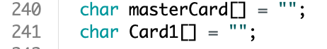

Fill in the master badge RFiD code in (e.g.: char masterCard[] = “9 160 86 233”) and for card1 the patient RFiD card.

You can add more by:

char Card2[] = "";

If you want one for the patient, you use it to add a badge/card.

sleutelsVerpleger.voegSleutelToe(Card2);

If you want one for the nurse, use this one to add a badge/card.

keysNurse.addKeyToe(Card2);

or you can add and RFiD badge/card in the menu, you will be able to use that too.

If you get an error that the library is not found, then you need to add them:

Servo.h

Wire.h

LiquidCrystal_I2C.h

MsTimer2.h

SPI.h

RFID.h

More information can be found on this website: <https://www.arduino.cc/en/guide/libraries>

Then you can upload it to the Arduino. Remove the USB and connect the power.

And you see you can open the safe with your batch.

.